MEMO

to: Hunter and Central Coast Regional PLanning Panel
from: Central coast council – environment and planning
subject: DA/919/2018 – HCC84 – Corrections to draft conditions
date: 19 november 2021
cc: -

Subsequent to the submission of the Council’s assessment report to the Hunter and Central Coast Regional Planning Panel (RPP) there are a number of matters for clarification raised by the RPP which are summarised below.
• Consideration and assessment of whether the proposal submitted for the review process is substantially the same as the previously refused DA. The Panel is required to consider this as per Section 8.3(3).
• A new recommendation drafted with reference to Section 8.2
• A new cover sheet which properly identifies the application as a Review of Decision and lists the draft instruments which have assessed in the report.
• Clarification about the easement over the drainage basin: it is required to be installed in Stage One, however it can’t be accessed until the internal roads are constructed in Stage Two.
• The Panel notes that the conditions of consent are not Staged and seeks that Council check that this is the way that Council wants this dealt with.
• The cover table indicates that the draft conditions have not been given to the applicant – is this correct? The Panel requires an understanding to the applicants response to the draft conditions, and therefore the Secretariat will reach out to the applicant today.

Discussion of matters raised
- Consideration and assessment of whether the proposal submitted for the review process is substantially the same as the previously refused DA. The Panel is required to consider this as per Section 8.3(3).

The proposed development which is the subject of the review of determination has been amended from the scheme that was originally refused. Amendments to the proposed development are permitted for the purposes of a review of determination under S.8.3(3) of the Act. Section 8.3(3) of the Act sates:
(3) In requesting a review, the applicant may amend the proposed development the subject of the original application for development consent or for modification of development consent. The consent authority may review the matter having regard to the amended development, but only if it is satisfied that it is substantially the same development.
It is noted that S8.3(3) requires the consent authority to be satisfied the amended is substantially the same development.
Borrowing from the jurisprudence surrounding the test of substantially the same development associated with S4.55(2) of the Act the key considerations are; does the amended proposal pose the material and essential features of the original, and are the consequences of the proposed development comparable to that of the original?
The key parameters of the original development in comparison to proposed development a summarised in the table below.
Stage | Original | Proposed
6a | Not Proposed | - Lot 601 2.555Ha (originally part of Stage 6)  - Basin and associated easements.
6b | The original development did not propose stages 6a & 6b, they were a singular stage 6 as described below  49 residential lots with access from Woongarrah Road to the west and an extension of Mataram Rd to the north. The proposed residential lots vary in size from 316m2 to 360m2.  1 (Lot 601) residue lot for future development with frontage to Sparks and Woongarrah Roads, access to be obtained from the proposed subdivision roads.  1 (Lot 651) easement and basin lot of 2253m2 | 48 residential lots with access from new roads connecting to Woongarrah Road to the west. The proposed residential lots vary in size from 330m² to 453m².
7 | 1 mixed use lot zoned B4 (1.422ha) for future development  43 residential lots varying in size 301m2 to 644m2 | One mixed use lot zoned B4 (1.116 ha) for future development.  44 residential lots with varying in size from 314m² to 654m².

The proposed development as amended is generally consistent with original development in relation to the area to be development, the number of lots to be created, the size and dimension of those lots and while there are changes to the location and design of the proposed roads as depicted in the figures below, the fundamental layout and configuration of the proposal is essentially the same.
There have been adjustments to the design of services, including the location of the basin and details provided with respect of the proposed earthworks and retaining provided. The provision of the aforementioned details has allowed for a proper consideration of the impacts of the development which was not possible with the original application, and in this regard the provision of additional details and/or the refining of the service and drainage design are considered to be substantially the same as the original development.

It is considered that the consequences of the original development were either not able to be fully determined or in other cases unacceptable. The consequences of the proposed development are in essence the same in nature as the original development for example, land clearing, provision of services, traffic generation and so forth. It rather is the case that the amended development has been found to have an acceptable impact. In this regard, the consequences of the amended development are not so foreign to those of the original that it would render a conclusion it was somehow not substantially the same development.

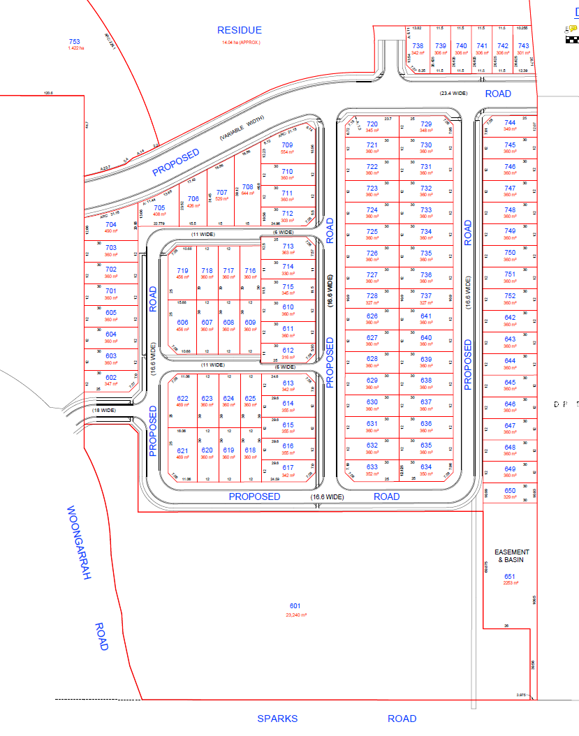
Figure 1: DA/919/2018 as determined

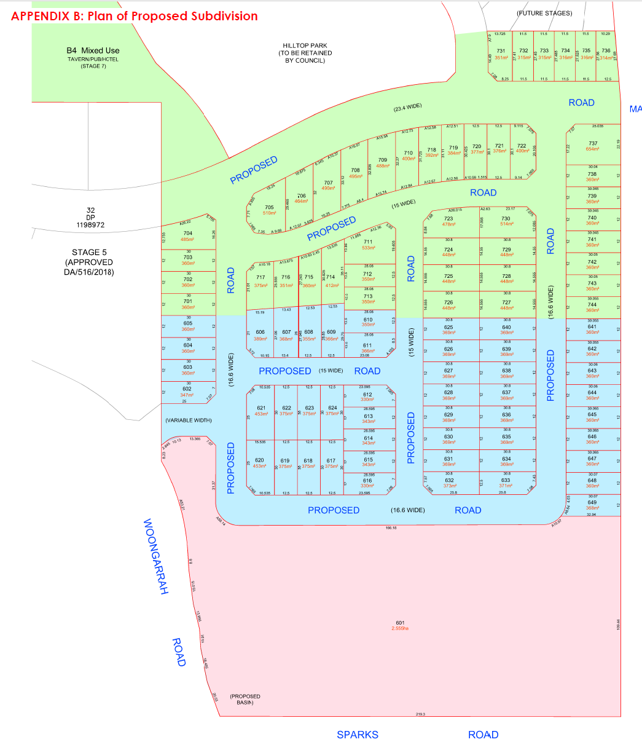
Figure 2: Proposed Subdivision

- A new recommendation drafted with reference to Section 8.2
The following recommendation replaces that from section 6 the assessment report dated 15 November 2021.
The Hunter Central Coast Regional Planning Panel, pursuant to Division 8.2 of the Environmental Planning and Assessment Act 1979 having undertaken a review of determination of Development Application No. DA/919/2018 , resolve to grant consent for a staged residential subdivision at 99-107 Sparks Road and 236-260 Hakone Road Woongarrah, pursuant to Section 8.4 of the Environmental Planning and Assessment Act 1979 subject to the attached conditions, and in so doing modify the reasons for the decision.

- A new cover sheet which properly identifies the application as a Review of Decision and lists the draft instruments which have assessed in the report.
This is shown below.
PANEL REFERENCE & DA NUMBER | DA/919/2018 – PPSHCC-84
PROPOSAL | The proposal comprises a review of determination pursuant to Division 8.2 of the Act of DA/919/2018 and seeks development consent for a Torrens title subdivision to be carried out in a number of stages (Stages 6a, 6b & 7) creating 92 residential lots between 314m² and 650m², one residential super lot, one commercial lot, and three residue lots
ADDRESS | Lot 1 DP 371647, Lot 1 DP 375712, Lot 1 DP 376264, Lot 41 DP 1200210, Lot 51 and 52 DP 561032 and Lot 54 and 55 DP 7527 - 99-107 Sparks Road and 236-260 Hakone Road Woongarrah NSW 2259
APPLICANT | Julie Garratley – Beveridge Williams
OWNER | Central Coast Council
DA LODGEMENT DATE | 10 June 2021 (Application for review of determination)
APPLICATION TYPE | Section 8.2 Review of Determination of an  Integrated Development Application
REGIONALLY SIGNIFICANT CRITERIA | Clause 3(b), Schedule 7 of the SRD SEPP: Land owned by Council and development with a CIV of more the $5M.
CIV | $11.2M as lodged (excluding GST)
CLAUSE 4.6 REQUESTS | N/A
KEY SEPP/LEP | - State Environmental Planning Policy (State and Regional Development) 2011  - State Environmental Planning Policy 55 – Remediation of Land  - State Environmental Planning Policy (Infrastructure) 2007  - State Environmental Planning Policy (Koala Habitat Protection) 2021  - Wyong Local Environmental Plan 2013  - Wyong Shire Development Control Plan 2013  - Chapter 1.2 – Notification of Development Proposals  - Part 4 – Subdivision  - Chapter 5.5 – Warnervale Town Centre  - Draft Central Coast Local Environmental Plan 2018  - Draft Design and Place State Environmental Planning Policy (Design and Place SEPP)  - Draft State Environmental Planning Policy Environment (SEPP Environment)  - Review of Clause 4.6 of the Standard Instrument LEP
TOTAL & UNIQUE SUBMISSIONS KEY ISSUES IN SUBMISSIONS | No Public Submissions Received
DOCUMENTS SUBMITTED FOR CONSIDERATION | - Plan of Proposed Subdivision of Lot 1 DP371647, Lott 1 DP375712, Lot 41 DP 1200210, Lots 54 & 55 DP 7527, Lots 51 & 52 DP 561032 & Lot 1 DP 376264 – Sheet 1, Issue L dated 5/11/2021, Prepared by Beveridge Williams  - Concept Engineering Drawings, Sheets 1-24, Issue P0, dated 10/11/2021, Prepared by Beveridge Williams
SPECIAL INFRASTRUCTURE CONTRIBUTIONS (S7.24) | Yes – Warnervale Town Centre – Special Contributions Area
RECOMMENDATION | Change of Decision to the Granting of Consent
DRAFT CONDITIONS TO APPLICANT | Yes – 19 November 2021
SCHEDULED MEETING DATE | 22 November 2021
PLAN VERSION | Select Date Version No
PREPARED BY | Nathan Burr
DATE OF REPORT | 19 November 2021

- Clarification about the easement over the drainage basin: it is required to be installed in Stage One, however it can’t be accessed until the internal roads are constructed in Stage Two.
The application included options for access via Woongarrah Road which were in proximity to the intersection of Sparks Road. This arrangement is not desirable as long-term solution from a traffic and pedestrian safety perspective. The conditions of consent reflect this, requiring the provision of access to the basin to be detailed in the engineering design drawings and subsequently an easement created for the access.
It is envisaged that in practice, the basin will be utilised for the purposes of a temporary sediment basin for soil and water management associated with construction of the subdivision. Ordinarily the sediment and water quality controls remain in place until a high proportion of the subsequent dwellings are constructed within the contributing catchment, and during the period, and for the maintance period subsequent to that. The basin is managed by the developer during this time. Access by Council is generally not required until the final hand over basin at which time it is envisaged that stage 6b will be completed and public road access available.

- The Panel notes that the conditions of consent are not Staged and seeks that Council check that this is the way that Council wants this dealt with.
The conditions of consent have been revised to provide clarity with respect to the requirements as they relate to the stages of development. Due to the nature of the provision of services and infrastructure there is a significant amount of overlap between stages, such that the staging refers more to the release of the lots than the actual construction.
It is noted that in the intervening time between the original drafting of the applicable conditions and the submission of the Draft Conditions to the HCC RPP, there has been update of the contributions rates for CPI. The conditions did refer to the periodic update of contribution rates however, for clarity it is considered that the current rate at the time of determination should be included in the recommended conditions.
Draft Condition 1.1 contains a reference a Civil Engineering package prepared by Northrop and this design package has been superseded by the addendum and plans prepared by Beveridge Williams. Given the Northrop Plans no longer have any work to do, it is considered that the reference to these plans within Condition 1.1 should be removed.
Refer to the attached schedule of revised draft conditions of consent.

- The cover table indicates that the draft conditions have not been given to the applicant –The Panel requires an understanding to the applicant’s response to the draft conditions.

A copy of the draft conditions have been circulated to the applicant for their review.

